Hundreds Chart & Recognizing Geometric Shapes
1st Grade Homework
Monday - Circle number 10. Circle all the numbers that count by 10s.
Tuesday – Put a box around number 5. Put boxes around all numbers that count by 5’s.
Wednesday – Draw a circle and a square.
Thursday – Draw a rectangle and a triangle.
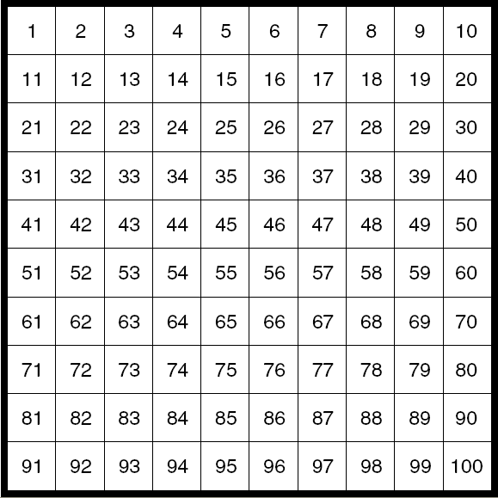

Circle: Rectangle:

Square: Triangle:

